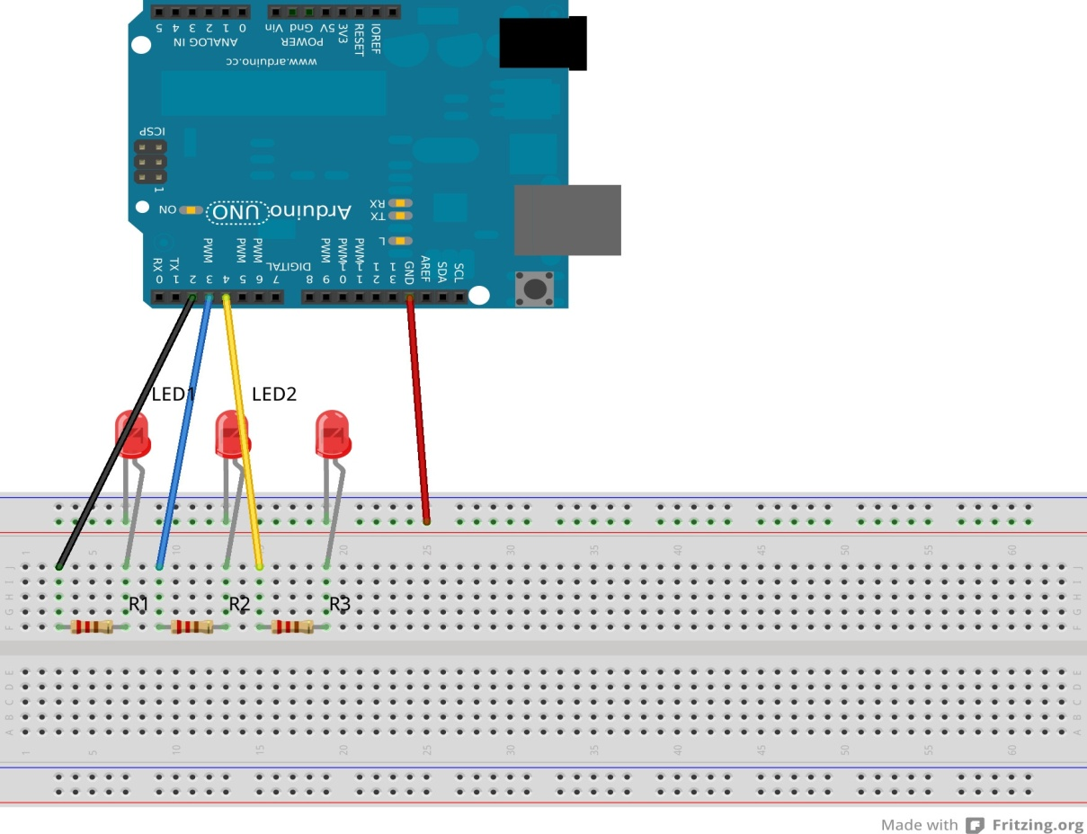

Theory
- Concept Used:
This expreiment involves the flashing of three LEDs onr by onenusing ARDUINO.
For this exp., the circuit needs to be connected as shown in the diagram above.
- Learning an observations:

Following observations were recorded during the experiment.
- The LEDs flash in the pattern set in the sketch of a particular experiment.
- The program uploaded into the ARDUINO starts executing as soon as the power is supplied and goes on executing in a loop till the power is supplied.
- There are certain time delays in between consequent LED flashes which are according to ones defined in the sketch.

- Problems and Troubleshooting:
- The problem faced while performing the experiment was the error in uploading which was “the program is not responding” error.
- The error was troubleshooted by re connecting the the USB cable tightly.
- Precautions:
The following precautions needs to be taken while performing this experiment .
- The connectins of the USB in both PC and ARDUINO both should be in sung.
- The USB of PC and ARDUINO shpuld be in working condition.
- The sketch should be logically and syntactically correct and germane to the experiment that needs to be performed.
- Look for the errors during compilation and upload the executable to the ARDUINO.

- Learning outcomes:
- Ability to distinguish between the various parts of the ARDUINO and learn the basic code of how circuit works.
- Ability to write the basic code required for reading or writing digital values from/to a pin.

